Instagram

1. Platform Overview
Instagram is a popular social media platform that allows users to share photos and videos with other users. It was designed to help people connect visually by sharing moments from their daily lives. Instagram is used by individuals, influencers, businesses, and organizations to communicate, promote content, and build communities.
Users can create personal or business profiles, upload content, interact with others through likes and comments, follow accounts they are interested in, and explore trending content. Instagram focuses mainly on visual communication, which makes it highly engaging and widely used across the world.
2. Platform Features
The main features of Instagram are:
- User profiles
- Photo and video posts
- Likes
- Comments
- Followers and following system
- Hashtags
- Explore page for content discovery

3. Real-World Problems Solved
Instagram solves many real-world problems related to communication and content sharing.

Real - World Problems | How Instagram Solves It
People wants to share their movements | Allows Photos and Videos to Upload
User want to Social interaction | Likes and comments feature
Difficulty in discovering new content | Hashtags and Explore system
Growing an audience | Followers and Following system
Business promotion | Business profiles and reach

Instagram makes communication faster, visual, and interactive for users.

4. Case Study

User Story
Arjun is a college student who loves traveling and photography. He wants to share his travel photos with others and gain recognition for his work. Initially, Arjun finds it difficult to reach a wider audience.

Challenges Faced
- Low visibility of posts
- Limited engagement
- Difficulty in reaching new users

Instagram’s Solution
Rahul uploads his travel photos with relevant hashtags. Other users like and comment on his posts. As engagement increases, his content starts appearing on the Explore page. Over time, Rahul gains more followers and builds a strong online presence.

Result

Instagram helps Rahul share his passion, connect with people, and gain recognition through its features.

5. Schema Design
Schema design represents how data is structured and stored in the database. Below are the main entities used in Instagram.

Entities and Attributes

Users
- user_id (Primary Key)
- username
- email
- password
- bio
- created_at

Posts
- post_id (Primary Key)
- user_id (Foreign Key)
- caption
- media_url
- created_at

Likes
- like_id (Primary Key)
- user_id (Foreign Key)

Comments
- comment_id (Primary Key)
- user_id (Foreign Key)
- post_id (Foreign Key)
- comment_text
- created_at

Followers
- follower_id
- following_id

Hashtags
- hashtag_id
- hashtag_name

6. Rationale Behind Design

The schema design is created to ensure data consistency, scalability, and efficiency.
- Separate tables are used to avoid data duplication.
- Foreign keys are used to maintain relationships between users and posts.
- Likes and comments are stored separately because many users can interact with a single post.
- This structure allows Instagram to handle millions of users efficiently.
The design aligns with Instagram’s goal of providing fast and scalable social interactions.

7. ER Diagram

The Entity Relationship (ER) Diagram visually represents the relationships between entities such as Users, Posts, Likes, and Comments.
- One user can create many posts.
- One post can have many likes and comments.
- Users can follow many users.

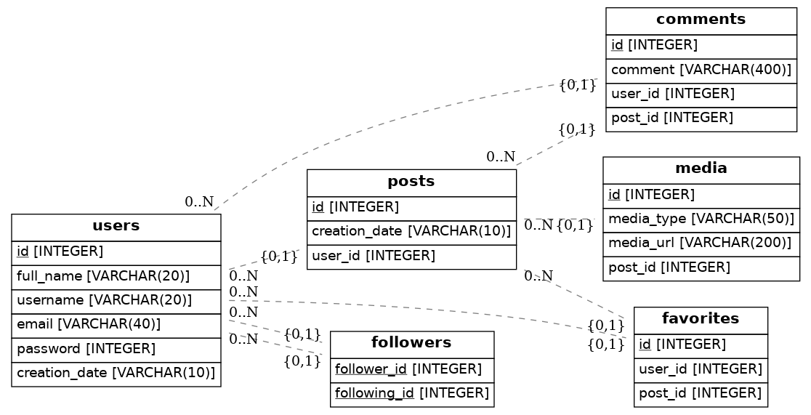

8. Conclusion
This project helped in understanding how large social media platforms like Instagram manage their data efficiently using proper schema design. By analyzing platform features, real-world problems, and database structure, this case study provides insight into how data architecture supports platform scalability and performance.

